

CS161 - Final Project

1. Feature

* New game
  + Choose mode (beginner, intermediate, expert, custom)
  + Change width, height and number of bombs of the table
* Load game
* Ranking
  + Local ranking
  + Global ranking
* Settings
  + Profile
    - Log in / Change password
    - Sign up / Log out
  + Change volume of musics
  + Change volume of sound effects
* Quit

2. Program structre

|  |  |
| --- | --- |
| Include | |
| C++ | <iostream>  <fstream>  <string>  <vector>  <algorithm>  <filesystem>  <chrono>  <tuple>  <cassert>  <queue> |
| SFML | <System.hpp>  <Window.hpp>  <Graphics.hpp>  <Audio.hpp> |
| Struct | |
| Tile | Tile(int, int)  std::pair <int, int> getData()  bool isBomb()  bool isEmpty()  int getAdjacentBombs()  bool isVeiled()  bool isMarked()  bool isOpened()  void mark()  void unmark()  void open() |
| Table | Table()  Table(int, int, int)  void inputData(std::istream&)  void outputData(std::ostream&)  int getNumRow()  int getNumCol()  int getNumBomb()  int getNumMarked()  bool isBomb(int, int)  bool isEmpty(int, int)  bool isSpecial(int, int)  int getAdjacentBombs(int, int)  bool isVeiled(int, int)  bool isMarked(int, int)  bool isOpened(int, int)  void setUp(int, int)  void mark(int, int)  void open(int, int, bool check = true)  int gameState()  void refresh()  void undo() |
| User | User()  User(std::string, std::string)  std::string getUsername()  std::string getPassword()  void changePassword(std::string) |
| Core | Core()  bool positionInBox(sf::Vector2i, sf::FloatRect)  sf::Vector2f centerPosition(sf::FloatRect, sf::FloatRect)  void gameMenu()  void profile()  void logIn()  void signUp();  void changePassword()  void newGame()  void mainGame()  void updateLocalRanking(int)  void updateGlobalRanking(int)  void ranking()  void settings()  void about()  void run() |

3. Instruction

a. Open the game

Double click the file “BlueSweeper.exe”.

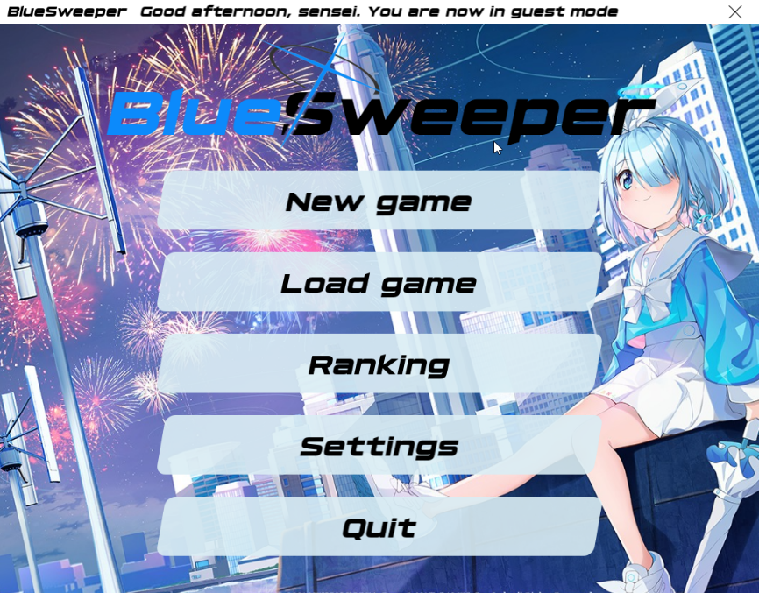

b. Sign in

Click “Settings” $→$“Profile” $→$“Sign up”.

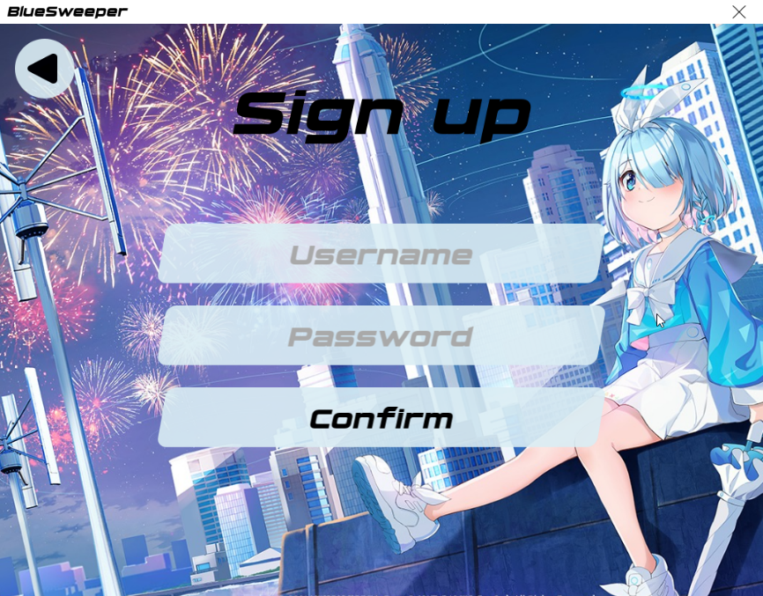

Then type your username and password using the keyboard.

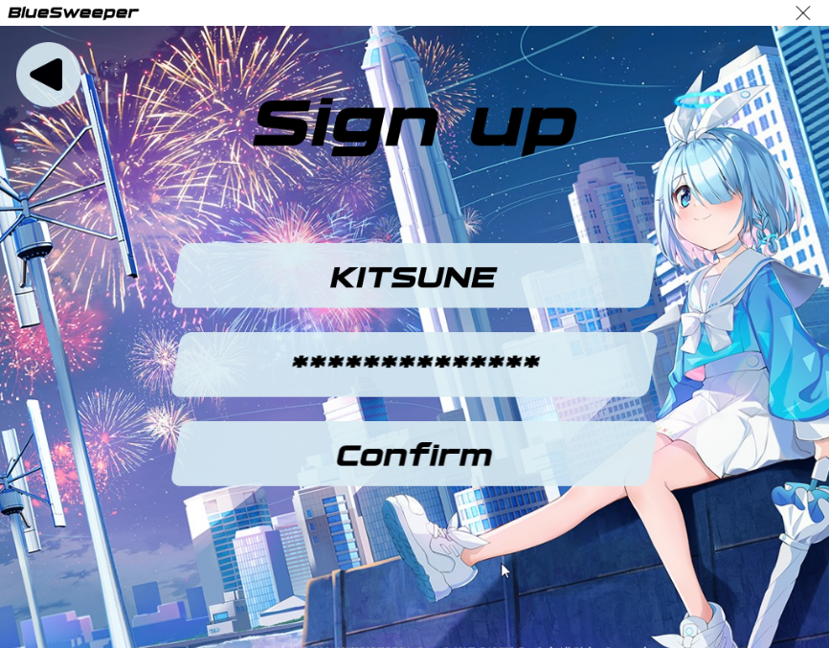

Then click “Confirm”.

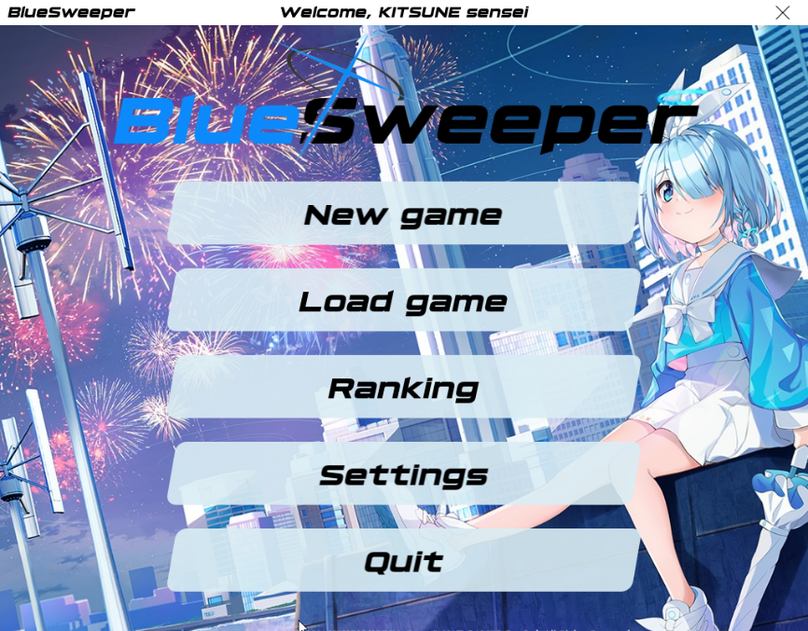

c. Log in

Click “Settings”“Profile”“Log in”.

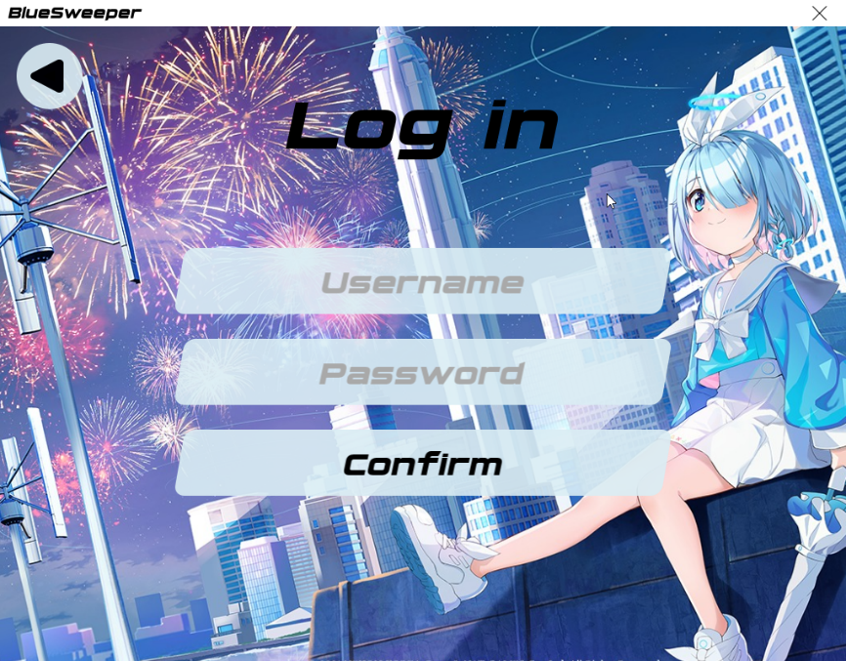

Then type your username and password using the keyboard.

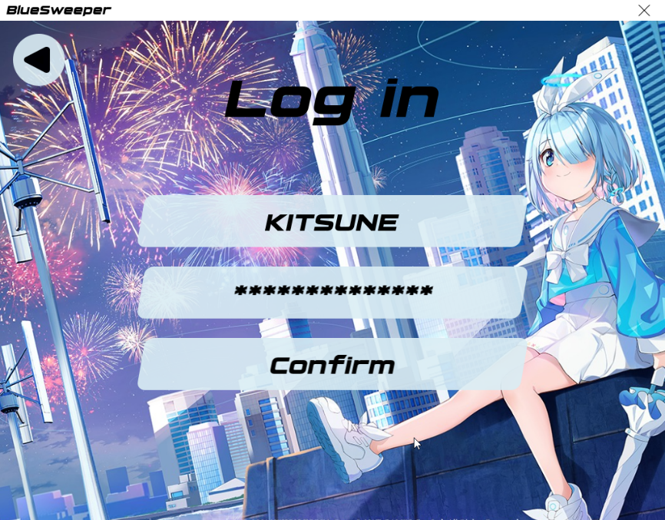

Then click “Confirm”.

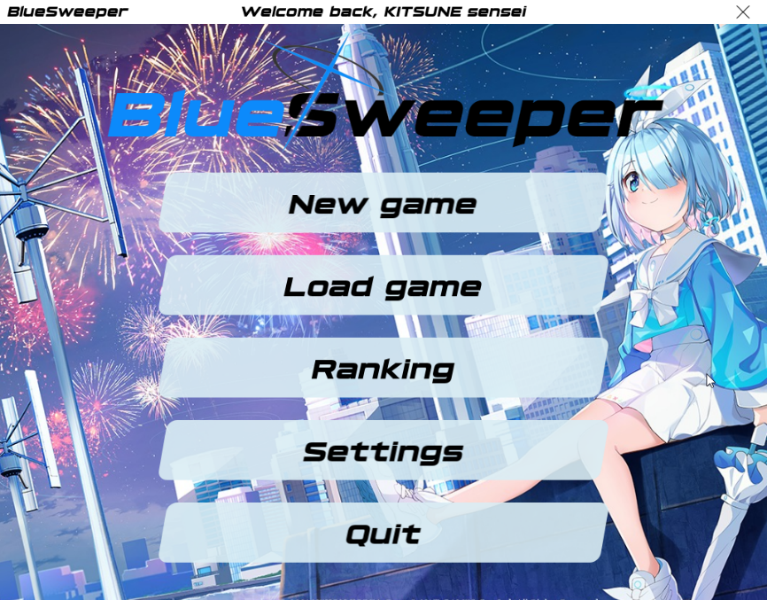

d. New game

Click “New game”.

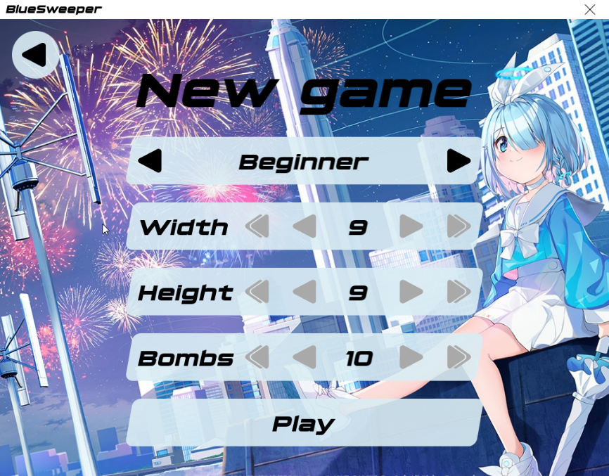

You can choose between beginner, intermediate, expert and custom mode. In custom mode, you can change the width, height and number of bombs in the game. Then click “Play” to play.

e. How to play

The board is divided into cells, with bombs randomly distributed. To win, you need to open all the cells. The number on a cell shows the number of bombs adjacent to it. Using this information, you can determine cells that are safe, and cells that contain mines. Cells suspected of being mines can be marked with a flag using the right mouse button.

To start a new game, you can click on the cycling arrow at the top of the board. The remaining number of bombs is displayed in the left, and the game timer is displayed in the right.

When you lose, you can continue playing by clicking the right arrow button at the top right corner. But your result will not be updated to the ranking.

f. Load game

When you leave an unfinished game, your game will be saved. So when you come back, you can load your last game and continue playing by clicking “Load game”.

g. Ranking

There are two types of rankings: Local ranking (only you) and Global ranking (common for everyone). When you win a game without using the “Continue playing” button, your time and date will be updated to the ranking.

Global ranking:

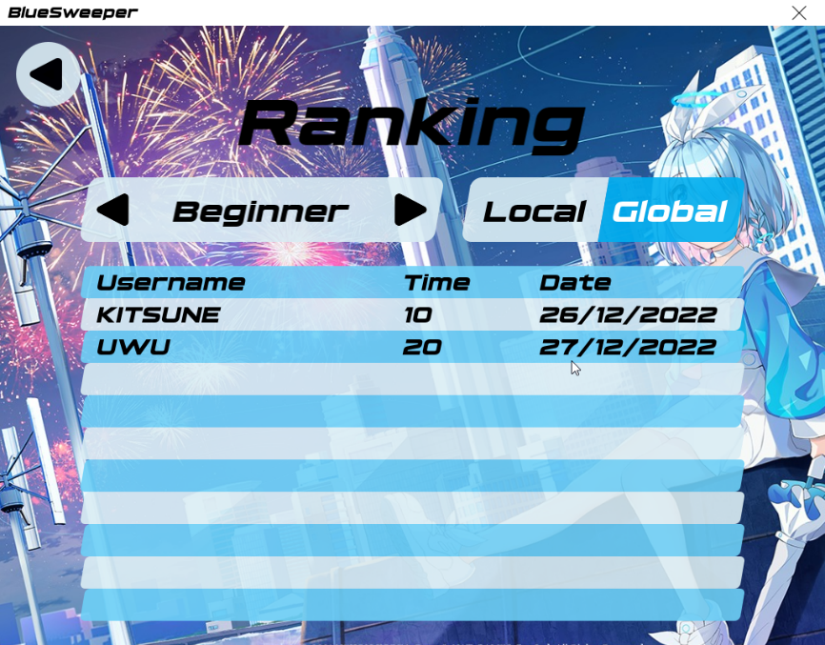\

Local ranking:

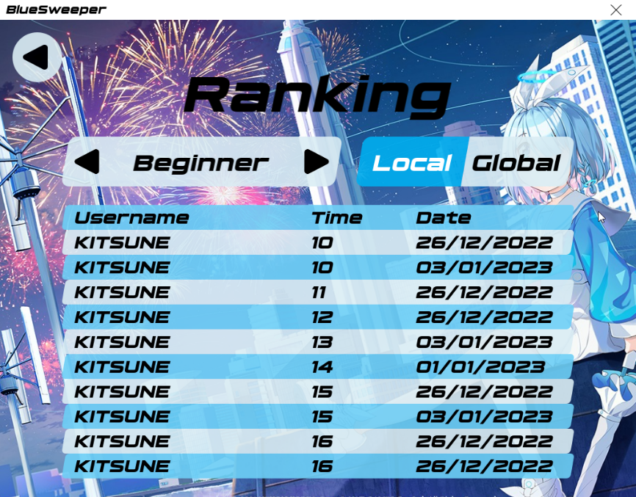

You can also see the rankings in other modes (except custom mode).

g. Settings

Click “Settings”.

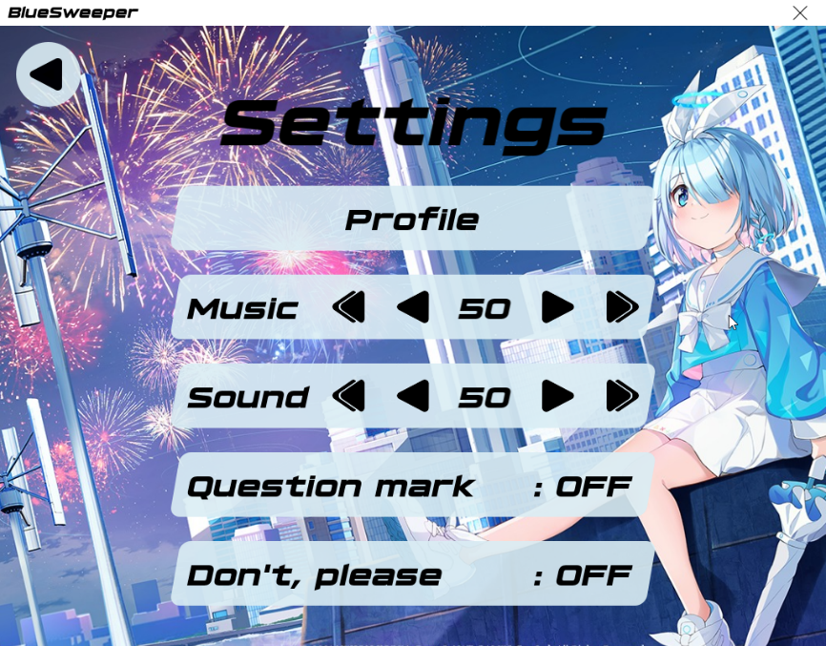

You can change the volume of musics, sound effects here. It also have some options.

4. Video demo

Click [here](https://youtu.be/80_4p-995v4).